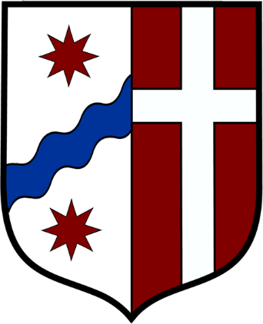
Notice
March 14, 2020

Dear brothers and sisters in Christ,

In accord with yesterday’s decree of Cardinal Cupich and the recommendations of civil authorities, the Monastery will have no public liturgy beginning at 9:00 a.m. today, March 14. Therefore, tonight’s planned Solemn Vespers is cancelled.
Because of the Cardinal’s decree, the usual Sunday obligation to attend Mass is not in effect.
The priests of the monastery will continue to offer Mass in private for the intentions that we have received.
The brothers will also be offering special prayers and penances, seeking God’s mercy in this time of uncertainty. We will be sharing more information on our website at www.chicagomonk.org.
Please join us in praying for the prudence of our leaders, for those suffering from COVID-19, and for health-care workers who are generously attending to the sick and vulnerable.

